NPC – Capstone Project Assignment
REPORT
Topic: Malware Analysis Sandbox Using VirtualBox or VMware

Submitted by: Siddhi Rajesh Lute
PRN Number: 2125UCSF1098
Semester: 3
Subject: NPC
Department: Cyber Security
College: Sanjivani University
Academic Year: 2026-27

1. Aim :
To set up an isolated virtual machine using Oracle VirtualBox and study the basic techniques used to observe system processes, network activity, and system changes in a controlled malware-analysis environment.

2. Objectives :
- To understand the concept and importance of a malware-analysis sandbox.
- To configure a Linux virtual machine using Oracle VirtualBox.
- To isolate the virtual machine from external network access.
- To monitor system processes and network activity using Linux commands.
- To understand snapshot creation and restoration.
- To study the role of online malware-analysis services such as VirusTotal.
- To understand the precautions required when analysing suspicious files.

3. Requirements :
- Computer system with Oracle VirtualBox installed.
- Kali Linux virtual machine.
- Sufficient memory and disk space.
- Linux terminal and monitoring commands.
- VirtualBox snapshot functionality.
- VirusTotal access for file analysis, where applicable.
- Screenshots of the practical steps and results.

4. Introduction :
A malware-analysis sandbox is a controlled environment used to study suspicious software or files while reducing the risk to the host computer and external systems. Virtualization software such as Oracle VirtualBox allows a separate operating system to run inside a virtual machine.
In a sandbox, security analysts can observe processes, network connections, and system behaviour. Snapshots provide a way to save a virtual machine's state and return to it after testing. Network isolation is also important because it reduces the possibility of unintended communication with external systems.
Malware analysis requires careful preparation, controlled testing, and accurate documentation. System-monitoring tools and file-analysis services can help analysts understand suspicious behaviour without relying on assumptions.

5. Software and Environment Configuration :
Parameter | Details
Virtualization software | Oracle VirtualBox
Guest operating system | Kali Linux
Virtual machine name | Siddhi
Network configuration | Network adapter disabled
Analysis environment | Isolated virtual machine
Recovery mechanism | VirtualBox snapshots
Monitoring tools | Linux terminal commands
File-analysis service | VirusTotal

6. Procedure :

Step 1: Open Oracle VirtualBox
Oracle VirtualBox was opened, and the existing Kali Linux virtual machine named Siddhi was identified.

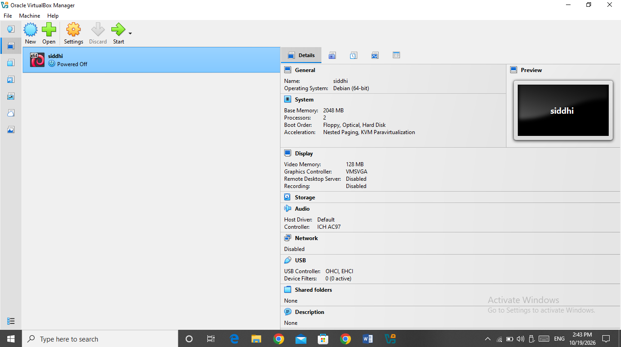
Figure 1: Kali Linux virtual machine displayed in Oracle VirtualBox.

Step 2: Configure the virtual machine
The virtual machine settings were opened, and the network adapter was disabled to isolate the guest operating system from external network access through that adapter.

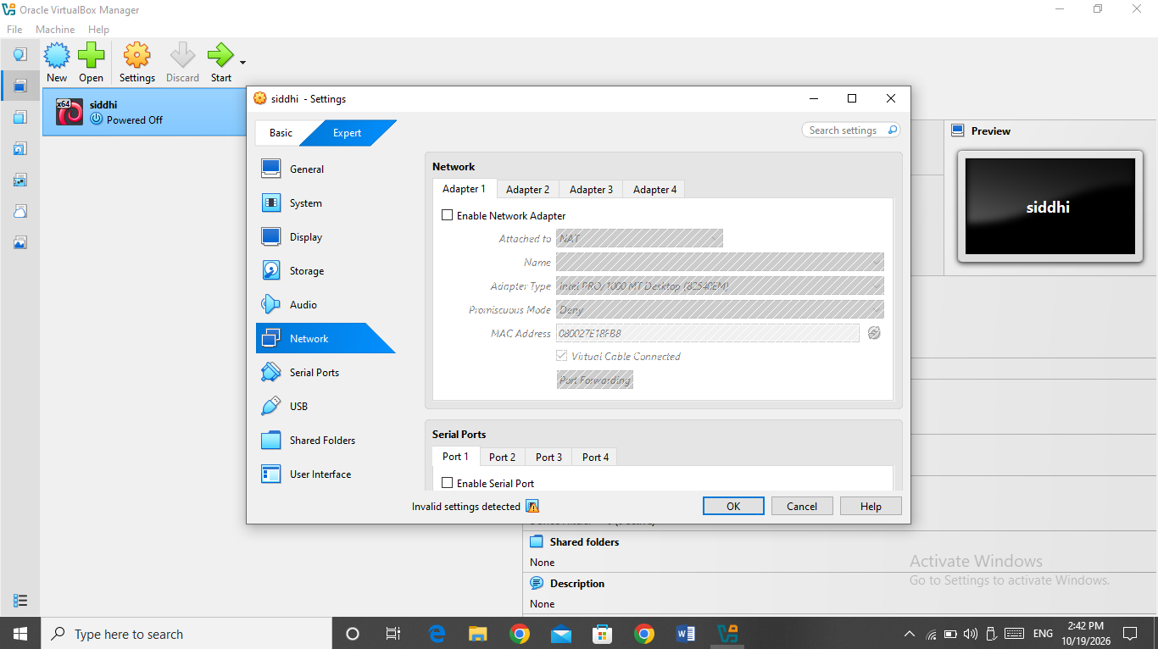
Figure 2: Network adapter settings in Oracle VirtualBox.

Step 3: Start Kali Linux
The Kali Linux virtual machine was started to access the Linux environment required for system monitoring and security analysis.

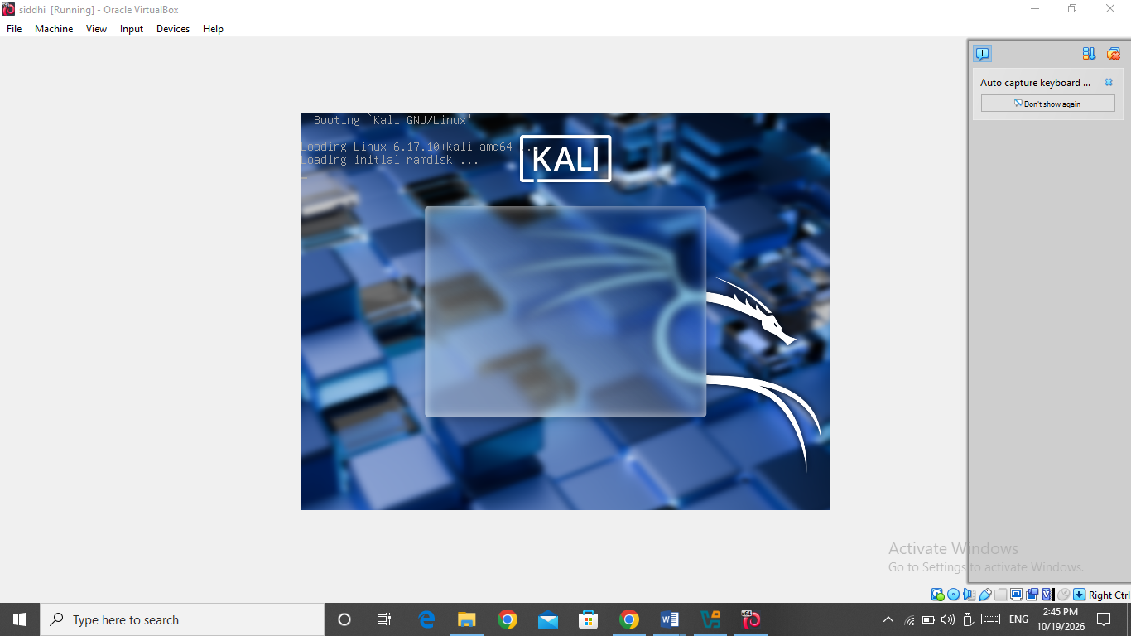
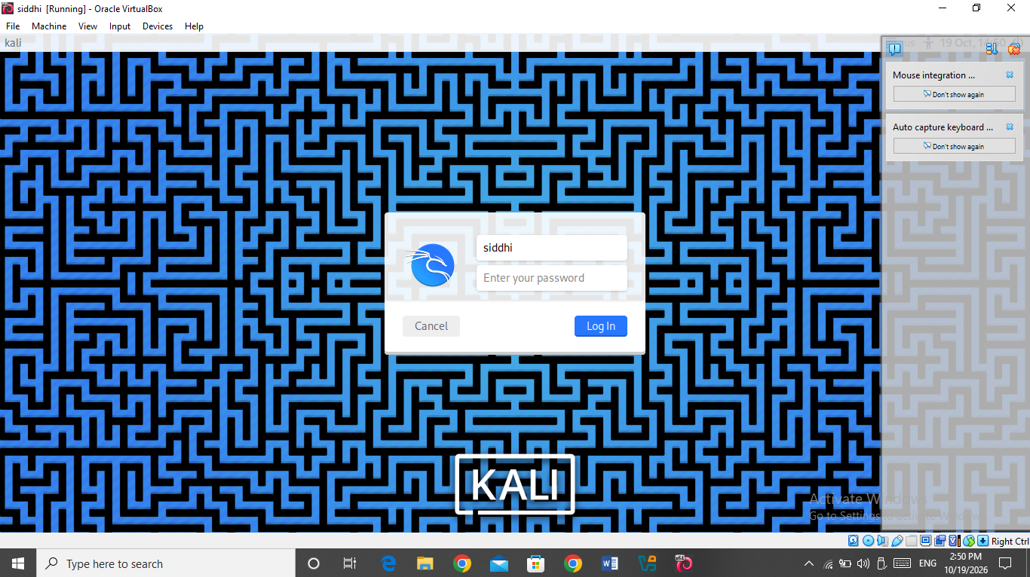
Figure 3: Kali Linux virtual machine startup/login screen.

Step 4: Record baseline system information
Before performing a controlled test, basic operating-system details, running processes, and network information can be collected. This baseline provides a reference for identifying changes during the experiment.

Step 5: Create a snapshot
A snapshot named Before Analysis can be created in VirtualBox to preserve the virtual machine's initial state. This provides a recovery point before controlled testing.
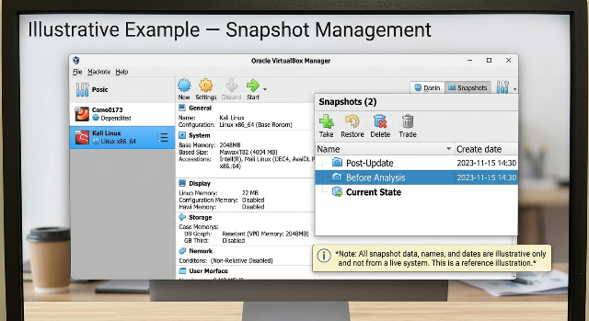
Figure 7: Illustrative example of snapshot management in Oracle VirtualBox.
Step 6: Perform controlled testing
A safe test activity can be carried out in the isolated virtual machine while observing the relevant system processes and network information. Suspicious files must not be executed on the host computer, and external network access should remain disabled during testing.

Step 7: Monitor system behaviour
Linux commands can be used to inspect processes, network interfaces, routing information, and listening sockets. The output can be compared with the baseline to identify changes associated with the test activity.

Step 8: Restore the virtual machine
After testing, the saved snapshot can be restored to return the virtual machine to its recorded state. This demonstrates the recovery purpose of snapshots in a controlled analysis environment.

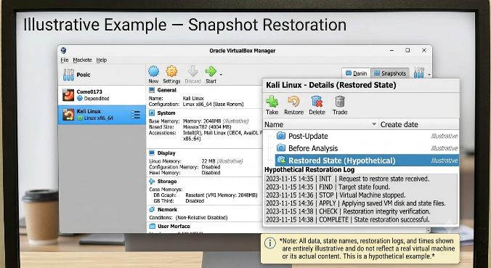
Figure 10: Illustrative example of snapshot restoration in VirtualBox.

7. Linux Commands Used for Monitoring :

A. Display operating-system information
cat /etc/os-release
This command displays information about the installed Linux distribution and its version.

B. Display kernel information
uname -a
This command displays the kernel name, version, architecture, and other system details.

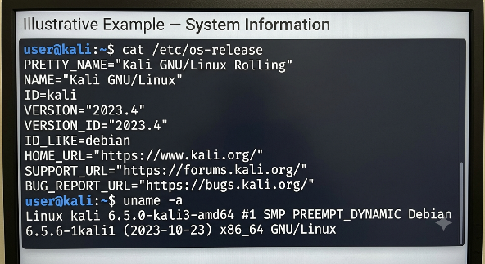
Figure 4: Illustrative example of Linux operating-system and kernel information.

C. List running processes
ps aux
This command lists running processes and associated details, including process identifiers and resource usage.

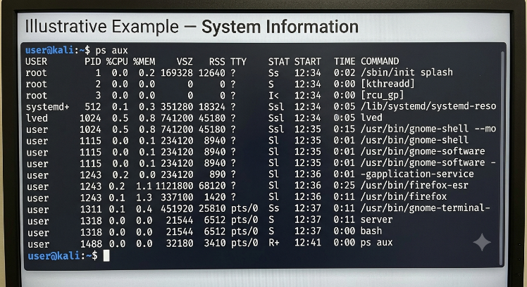
Figure 5: Illustrative example of running-process monitoring in Linux.

D. Display network interfaces
ip addr
This command displays the available network interfaces and their assigned addresses.

E. Display routing information
ip route
This command displays the system's network routing table.

F. Display listening sockets
ss -lntup
This command displays listening TCP and UDP sockets and, where permitted, associated process information.
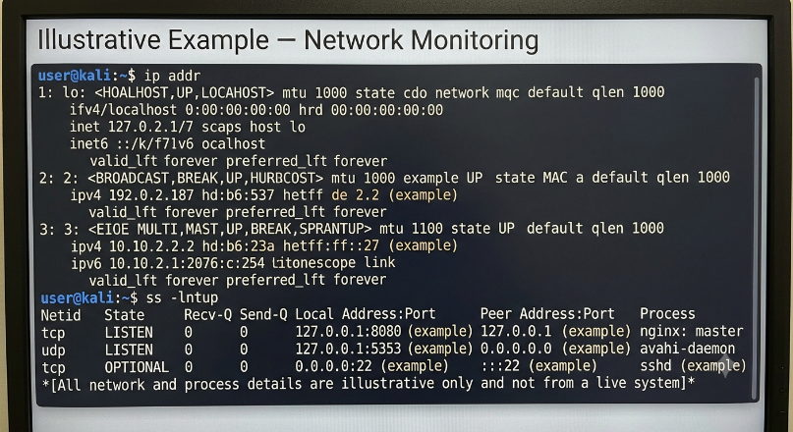
Figure 6: Illustrative example of network-interface and listening-socket monitoring.

8. Safe Demonstration of Process and Network Monitoring :
A harmless local web server can demonstrate how a process and listening socket appear in monitoring tools.
Command:
python3 -m http.server 8000 --bind 127.0.0.1
This starts a simple HTTP server bound to the loopback address, so it listens only on the local machine. Its process and listening socket can be observed using:
ps aux
ss -lntup
The server can then be stopped using Ctrl+C.
This demonstration illustrates basic monitoring techniques. It is not a malware sample and does not implement a reverse shell or bind shell.
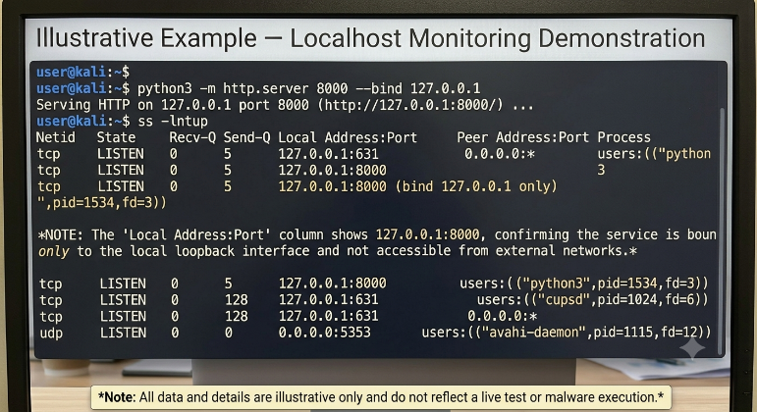
Figure 8: Illustrative example of localhost process and network monitoring.

9. Monitoring and Observation :
During a controlled analysis, the following categories of information are useful:
Area | Monitoring method | Purpose
Operating system | cat /etc/os-release | Identify the Linux distribution
Kernel | uname -a | Identify kernel details
Processes | ps aux | Observe running processes
Network interfaces | ip addr | Inspect interface configuration
Routing | ip route | Inspect network routes
Listening sockets | ss -lntup | Observe listening network services
Recovery | VirtualBox snapshot controls | Return to a saved virtual-machine state
Comparing system information before and after a controlled activity helps identify changes. Any reported findings should be based on the actual command output and screenshots.

10. VirusTotal Analysis :
VirusTotal is an online service that analyses submitted files using multiple security engines and other analysis tools. It can help identify whether a file is flagged by participating security vendors.
The general analysis procedure is:
- Select a permitted, non-confidential test file or use an existing report for a known file.
- Obtain the file's SHA-256 hash if required.
- Search for the hash or submit the file only when authorised and appropriate.
- Review the detection summary and available analysis details.
- Record the actual findings in the report.
The detection results may differ between security engines. A detection does not automatically establish that a file is malicious, and a zero-detection result does not guarantee that a file is safe.

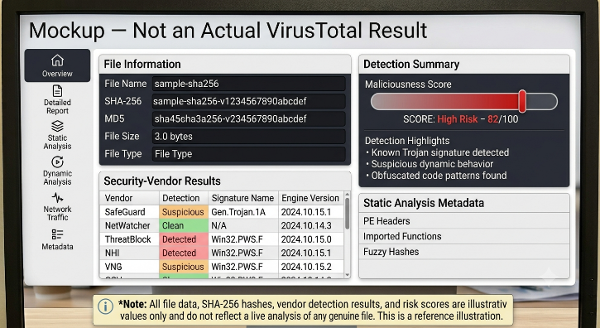
Figure 9: Mockup illustrating the layout of a file-analysis report; not an actual VirusTotal result.

11. Precautions :
- Keep the virtual machine isolated during controlled testing.
- Do not execute unknown files on the host operating system.
- Do not use personal credentials or confidential information in the test environment.
- Create a snapshot before making experimental changes.
- Observe system and network activity using appropriate monitoring commands.
- Avoid uploading confidential or unauthorised files to public analysis services.
- Restore the saved snapshot after testing when appropriate.
- Record actual findings accurately and use screenshots from the relevant environment.

12. Result :
The initial VirtualBox setup was inspected, and the network adapter of the Kali Linux virtual machine was disabled as an isolation measure. The practical demonstrates the principles of a malware-analysis sandbox, including virtual-machine isolation, process and network monitoring, snapshot-based recovery, and safe file-analysis practices.

13. Conclusion :
This practical explains how Oracle VirtualBox can be used to prepare an isolated Linux environment for security-analysis exercises. Linux commands such as ps aux, ip addr, ip route, and ss -lntup help inspect system processes and network activity. Snapshots provide a recovery mechanism, while services such as VirusTotal can support file analysis when used appropriately.
The practical highlights the importance of isolation, monitoring, recovery, and accurate documentation in a malware-analysis workflow.

